Xilisoft DVD Copy Express Tutorial
Xilisoft DVD Copy Express is an extremely easy-to-use DVD backup and DVD clone tool which helps you copy DVD movie with excellent DVD copying quality in full disk mode or main movie mode. It can copy DVD movie to DVD folder, DVD disc or ISO file and burn ISO file or DVD folder to DVD disc. It is easy to use with super fast copy speed (only about 30 minutes)!
- Download and install Xilisoft DVD Copy Express.
- Run Xilisoft DVD Copy Express. Specify the "Source" and "Target" By Selecting from the "Source Combo box" and "Target Combo box".
Tip: Xilisoft DVD Copy Express supports three types of DVD source and DVD target, you can specify source DVD as DVD drive, DVD folder or image file. So, you can copy DVD to DVD, back up DVD disc to ISO or DVD folder and burn ISO or DVD Folder to DVD disc.
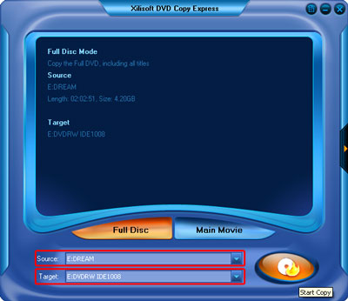
Copy DVD to DVD
Insert a DVD-Video disc in your DVD-ROM. Xilisoft DVD Copy Express will auto-detect all drives on your computer and show the information in the "Source" combo box and "Target" combo box. Specify source DVD drive in "Source" combo box and specify target drive in "Target" combo box.
Tip: You may have only one DVD ROM, but it's no need to worry about it. Just select the same DVD Drive as the " Source" and "Target ", then following the steps below.
Back up DVD disc to ISO or DVD Folder
Insert a DVD-Video disc in your DVD-ROM. Xilisoft DVD Copy Express will auto-detect all drives on your computer and show the information in the "Source" combo box. Specify source DVD drive in "Source" combo box, and specify target DVD folder or target ISO image in "Target" combo box.
Burn ISO or DVD Folder to DVD disc
Insert a blank DVD disc in your DVD RW Drive. Xilisoft DVD Copy Express will auto-detect all drives on your computer and show the information in the "Target" combo box. Specify target DVD drive in "Target" combo box, and specify source DVD folder or source ISO image in "Source" combo box.
- Select certain output mode as you need. There are two modes – Full Disk and Main Movie.
Tips:
Full Disk mode: You can select the mode by clicking "Full Disk" button. It will copy the Full DVD including all titles.
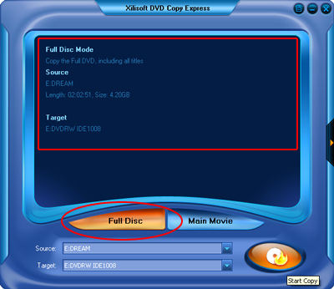
Main Movie mode: You can select the mode by clicking the "Main Movie" button. It will copy the longest title, get rid of some not important audio or video.
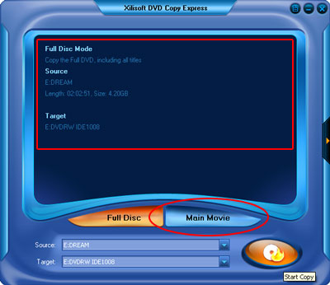
- You may do some advanced settings in the "Setting Panel" by clicking the "Expand" button on the right of the main interface. It allows you to change Temporary file folder, DVD volume, Audio track, Subtitle.
Note: The disc of temporary file folder needed 4.2G free space.
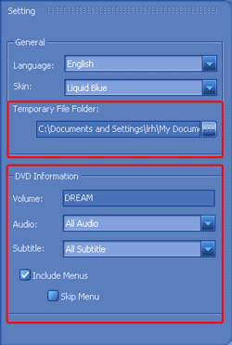
- Click "Start Copy" button to start copying.
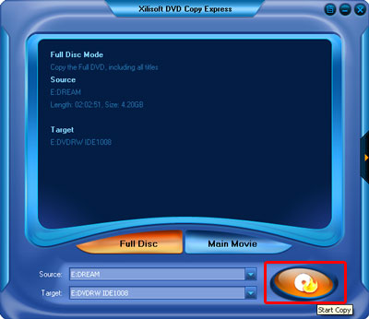
Note: If you copy from a DVD-Video disc to a blank DVD disc. Xilisoft DVD Copy Express will pop up a message box reminding you to select target disc type. There are three options (D5, D9, Custom ) to select.
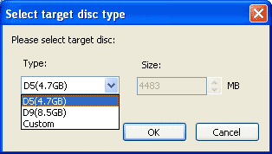
- Copy to Temporary File Folder
In this step, Xilisoft DVD Copy Express will copy the source DVD to your computer temporary file folder. When copying, it will display the copying progress in main interface.
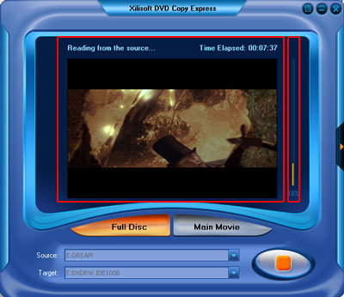
- Copy to Target
After the source DVD is copied to temporary file folder in your hard disk, it will begin to copy the temporary file to your target.
Note: If you choose to copy DVD to a DVD disc, here, it will pop up a message box telling you "Please insert an empty disc to write to...". At the same time your DVD RW Drive will be ejected. Insert a blank DVD, then click " Retry" button.
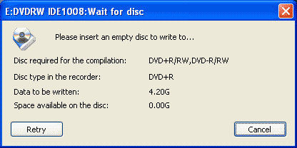
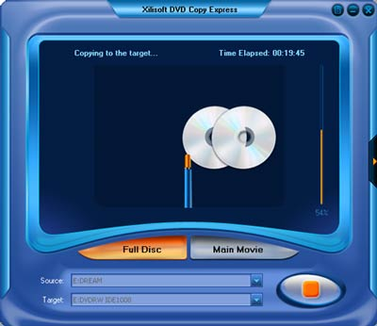
- Complete Copy
Once copying completed, Xilisoft DVD Copy Express will pop up a message box showing copy information including "Source", "Target", "Copy mode", "Compress ratio" and "Time".
