Vegas Family Comparison

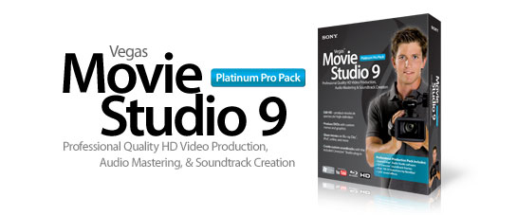

Vegas Family Comparison
FEATURE | Vegas Movie Studio | Vegas Movie Studio Platinum | Vegas Movie Studio Platinum Pro Pack | Vegas Pro
General
Includes DVD Architect 5.0 software
Includes DVD Architect Studio 4.5 software
DVD authoring and burning
Blu-ray Disc burning
(Vegas Timeline)
Blu-ray Disc burning
(DVD Architect)
5.1 surround mixing including film-style panning
5.1 surround and stereo AC-3 encoding
Interactive "Show Me" tutorials
Comprehensive window docking options, recallable window layouts
Includes Sound Forge Audio Studio 9
Includes 1,001 Sound Effects
Includes New Blue 3D Transitions and Effects
Dark color palette UI
Video
Red Eye Reduction (stills)
Enhanced video monitoring (DV and DVI) | DV | DV | DV
Simultaneous video monitoring (local and external monitor)
Number of video tracks | 4 | 4 | 4 | Unlimited
Number of video events per track | Unlimited | Unlimited | Unlimited | Unlimited
Video Preview Window
Video effects | Nearly 300 | Over 350 | Over 350
2D and 3D video transitions | Over 200 | Over 200 | Over 300
Credit rolls/text animation
Chroma Key/"Green Screen" effect
Advanced color correction tools |  | Primary color correction | Primary color correction | Primary, Secondary and Advanced Color Curves
Professional lighting effects
Video scopes: WFM/Vector/Parade/Histogram
ProType Titler
XDCAM Support
HDV/AVCHD
AVCHD and XDCAM EX Device Explorer
32-bit float video processing
SD/HD-SDI support
Gradient wipe transition
Support for gigapixel images
4k project support (up to 4096x4096)
Audio
Broadcast Wave format support
Gracenote CDDB support
Max bit-rate/bit depth | 16-bit/48kHz | 16-bit/48kHz | 16-bit/48kHz | 24-bit/192kHz
Number of audio tracks | 4 | 4 | 4 | Unlimited
Number of audio effects | Over 10 (ExpressFX and track) | Over 20 DirectX effects | Over 20 DirectX effects | Over 35 w/5.1 FX
Effects package folders
DirectX® plug-in effects support | (no automation) | (no automation) | (no automation)
VST plug-in effect support
Audio envelopes | Volume/Pan | Volume/Pan | Volume/Pan | Volume/Pan/FX
Music Soundtracks | 360 | 360 | 360
ACID loop properties support
On-the-fly punch-in recording
Audio restoration tools
ASIO™ driver support
Auto-input record monitoring
Master, auxiliary, and effects bus tracks
Multiple record takes
Red Book Audio CD Mastering/Burning
Audio and video timestretching
Editing and Media Management
Project and Make Movie Wizards
Real-time nondestructive editing
Cursor object snapping across events and timeline
Envelope "brush" painting
Envelope automation recording
Keyboard trimming and event shuffling
Tape-style audio scrubbing
Project nesting
AAF import/export
System wide media management
A/V synchronization detection and repair
Real-time event reverse
Video track motion control
Application scripting
Hardware/Capture/Export
Integrated publish to YouTube
External control surface support
AJA Xena LH, LHe, LS, and LSe board support (Digital only)
Export directly to PSP® (PlayStation®Portable) system
Render to Apple® iPod® compatible format
Windows Media® 11 support
Publish to the web at ACIDplanet.com
DV batch capture and scene detection
HDV capture
Print-to-tape tools
VideoCD and Multimedia CD Burning
MP3 open and save
MPEG 1&2 import and encoding
Customizable user templates
Capture to Compressed Sony MXF format from SD/HD-SDI
Support for OpenEXR and DPX
Support for RED ONE™ (.r3d) files

