
Xpress Recovery2 Introduction
Xpress Recovery2 is designed to provide quick backup and restoration of hard disk data. Supporting Microsoft operating systems including Windows Vista/XP/2K/NT/98/Me and DOS, and file systems including FAT16, FAT32, and NTFS, Xpress Recovery2 is able to back up data on hard disks on PATA and SATA IDE controllers. After Xpress Recovery2 is executed from CD-ROM for the first time, it will stay permanent in your hard disk. If you wish to run Xpress Recovery2 later, you can simply press F9 during system bootup to enter Xpress Recovery2 without the CD-ROM. System requirements:
- Intel x86 platforms
- At least 64M bytes of system memory
- VESA-supported VGA cards
How to use the Xpress Recovery2Initial access by booting from CD-ROM and subsequent access by pressing the F9 key: Steps: After entering BIOS Setup, go to Advanced BIOS Feature and set to boot from CD-ROM. Save the settings and exit the BIOS Setup. Insert the provided driver CD into your CD-ROM drive. Upon system restart, the message which says "Boot from CD/DVD:" will appear in the bottom left corner of the screen. Press any key to enter Xpress Recovery2. After the steps above are completed, subsequent access to Xpress Recovery2 can be made by simply pressing the key during system power-on. 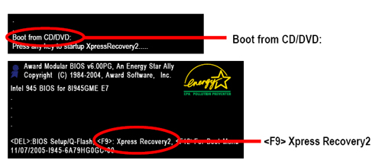
*NOTE:
- For the first time of use Xpress Recovery2, user have to assign BIOS Boot up option to "Boot from CD-ROM", and put Driver CD into assigned optical drive. After reboot the system, when user's screen appears "Press any key to startup Xpress Recovery2", then press any key to run the Xpress Recovery2 program.
- If user had experienced and installed Xpress Recovery2 application in PC before, user can run the Xpress Recovery2 application by press "F9" during boot up sequence.
- If you have already entered Xpress Recovery2 by booting from the CD-ROM, you can enter Xpress Recovery2 by pressing the key in the future.
- System storage capacity and the reading/writing speed of the hard disk will affect the data backup speed.
- It is recommended that Xpress Recovery2 be immediately installed once you complete installations of OS and all required drivers as well as software.
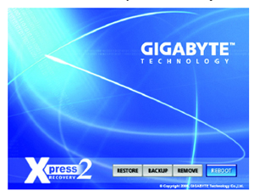
The Main Screen of Xpress Recovery2
- RESTORE: Restore the backed-up data to your hard disk. (This button will not appear if there is no backup file.)
- BACKUP: Back up data from hard disk.

- REMOVE: Remove previously-created backup files to release disk space.
(This button will not appear if there is no backup file.)

- REBOOT: Exit the main screen and restart the system.
Limitations:
- Not compatible to Xpress Recovery.
- For the use of Xpress Recovery2, a primary partition must be reserved.
- Xpress Recovery2 will store the backup image file at the end of the hard disk,so user must reserve enough unallocated hard drive partition space in advance. (A minimum 4GB is recommended but the actual space is dependent on the size of the data to be backed up)
- Capable of backing up hard disks installed with Windows operating systems including DOS and Windows Vista/XP/2K/NT/98/Me.
- USB hard disks are currently not supported.
- Does not support RAID/AHCI (class code 0104/0106) hard disks.
- Capable of backing up and restoring only the first physical hard disk.
Hard disks detection sequence is as follows:
  - PATA IDE primary channel
  - PATA IDE secondary channel
  - SATA IDE channel 1
  - SATA IDE channel 2
  - SATA IDE channel 3
  - SATA IDE channel 4
Precautions:
- It is normal that data backup takes longer time than data restoration.
- Xpress Recovery2 is compliant with the GPL regulations.
- On a few motherboards based on Nvidia chipsets, BIOS update is required for Xpress Recovery2 to correctly identify RAID and SATA IDE mode. Please contact your motherboard manufacturer.
- Xpress Recovery2 supports only PATA hard disks and not SATA hard disks on the following motherboards:
GA-K8U
GA-K8U-9
GA-K8NXP-SLI
GA-K8N Ultra-SLI
GA-K8N Pro-SLI
GA-K8NXP-9
GA-K8N Ultra-9
GA-K8NF-9 (PCB Ver. 1.0)
GA-K8NE (PCB Ver. 1.0)
GA-K8NMF-9
GA-8N-SLI Royal
GA-8N-SLI Pro
GA-8N-SLI

