Microsoft Office SharePoint Designer 2007

February 2006



Table of Contents

Cover is for   
position only

Overview of Microsoft Office SharePoint Designer 2007 1

Build SharePoint Applications Quickly, Without Writing Server Code 2

Automate Business Processes with Workflow Designer 2

Customize SharePoint Sites to Meet Your Needs 2

Manage Your SharePoint Sites with Confidence 3

Build SharePoint Applications Easily 5

Taking Advantage of Professional Design Tools 5

Access and Integrate Data from Multiple Sources 6

Extend and Customize Downloaded SharePoint Applications 8

Automate Business Processes 9

Automating with a Rules-Based Workflow Engine 9

Revising Workflows as Needs Change 11

Customize SharePoint Sites 13

Build and Change Page Layouts Quickly 13

Design Pages Productively 14

Minimize Deployment Concerns with a Safety Net 15

Find, Test, and Fix Problems Quickly 15

Manage Your Site with Confidence 18

Defining Contributor Settings and SharePoint Roles 18

Protecting What Works 19

Summary 21

Resources 22

Office SharePoint Designer 2007: Highlights Tab 22

Office SharePoint Designer 2007: New Interface Tab 22

Office SharePoint Designer 2007: Why Upgrade? 22

Office SharePoint Designer 2007: Demo Tab 22

Office SharePoint Designer 2007: FAQ 22

Office SharePoint Designer 2007: Overview 22

Office SharePoint Designer 2007: System Requirements 22

Top 10 Reasons to Upgrade 22

System Requirements 23

# Overview of Microsoft Office SharePoint Designer 2007

Welcome to Microsoft® Office SharePoint® Designer 2007, a member of the 2007 release of the Microsoft Office system. The 2007 release is an integrated system of programs, servers, and services for information workers.

Office SharePoint Designer 2007 is based on Microsoft Office FrontPage® technologies. The new name reflects the emphasis on creating and customizing Microsoft SharePoint Web sites and building applications on the SharePoint platform.

Office SharePoint Designer 2007 is specifically designed to help you create and customize Web sites and workflows built with SharePoint Products and Technologies (Microsoft Windows® SharePoint Services and Microsoft Office SharePoint Server 2007). It provides all the tools that IT professionals and solution creators need to develop SharePoint-based applications and workflow solutions that enhance organizational agility and business process automation. Creating a typical SharePoint site involves these steps:

* Page layout and design
* Master page creation
* Cascading style sheets (CSS) edit/apply
* List/Content Type design
* Creation of sample data
* Web Part page creation
* Web Part hookup
* No-code data view/forms
* No-code workflows

Coupled with the other SharePoint-enabled applications in the 2007 release of the Microsoft Office system, Office SharePoint Designer 2007 will help make it easier than ever for individuals and teams to collaborate effectively.

### Build SharePoint Applications Quickly, Without Writing Server Code

With Office SharePoint Designer 2007, you can design SharePoint workflows and applications without having to use traditional procedural coding languages or techniques. Instead, SharePoint Designer provides you with easy-to-use tools that you can use to:

* Build conditional views and forms with validation.
* Read, write, and present data from a variety of data sources—such as XML files, SQL databases such as Microsoft SQL Server™ 2005, and Web Services.
* Compile data from multiple sources to create flexible, customized views and reports.
* Build Web Part pages and connect Web Parts to create sophisticated business applications.

### Automate Business Processes with Workflow Designer

Office SharePoint Designer 2007 makes it easy to create and modify rules-based workflow applications. With the Workflow Designer tool in Office SharePoint Designer 2007 you can use drop-down lists and check boxes to identify the events that trigger a workflow. You can then specify the actions and responses that follow, and even identify the conditions under which other workflow events will occur.

### Customize SharePoint Sites to Meet Your Needs

Office SharePoint Designer 2007 provides an intuitive what-you-see-is-what-you-get (WYSIWYG) environment for quickly creating and customizing SharePoint sites and applications. You can take advantage of the power of ASP.NET as well as industry standard Extensible Hypertext Markup Language (XHTML) code and cascading style sheets (CSS) to build SharePoint sites that meet your needs and that meet industry standards for browser compatibility and accessibility.

* The WYSIWYG environment enables you to view and modify pages with precise rendering of CSS and ASP.NET technologies.
* Microsoft IntelliSense® technologies help eliminate errors when working with CSS, ASP.NET, and XHTML tags. IntelliSense can also suggest commands based on the work you are doing in the Office SharePoint Designer 2007 code view, enabling you to develop pages more quickly and efficiently.
* Support for multiple dockable task panes means that you can work with exactly the information and views that you need to develop sites and applications effectively.

### Manage Your SharePoint Sites with Confidence

Site administrators and information technology (IT) managers can control exactly how information workers interact with the SharePoint site and applications, helping to ensure that they do so in a way that complies with IT policies and procedures. Using Office SharePoint Designer 2007 contributor settings, an administrator can modify existing SharePoint roles to:

* Define precisely what users can or cannot do in a SharePoint environment—including what kinds of content they can add, change, or delete; where they can make such changes; whether they can make changes to master pages and CSS; whether they can access the code view, and more.
* Minimize the chance that a user might inadvertently break or corrupt a site.

Office SharePoint Designer 2007 in Action

Barbara Sankovic, a marketing business analyst for Fabrikam, is responsible for building and customizing a new SharePoint site that will be used for collaborating on the development of videotaped customer case studies. The goal is to optimize the cooperation between the different case study creation participants and stakeholders and decrease the costs of development through better coordination.

Barbara needs a better way to facilitate the following tasks:

* Coordinate the work of writers, content experts, and videographers.
* Work with customers and set up times for interviews.
* Arrange for transcriptions after the videos have been shot.
* Keep track of video stock and equipment so that the videographers have the right materials on hand when shooting.

Using Office SharePoint Designer 2007, Barbara quickly and easily designs a site that can help the team keep track of all the details associated with each video project.

# Build SharePoint Applications Easily

Office SharePoint Designer 2007 provides an intuitive interface that enables you to create and refine SharePoint sites and build workflow-enabled SharePoint applications and reporting tools quickly, easily, and all within the context of an IT-managed environment. Using SharePoint Designer, you can quickly become a solution creator, even if you are not a professional programmer or application developer.

With SharePoint Web Parts and ASP.NET controls, you can easily build whole SharePoint applications for your organization, with custom list views and custom forms, data from external sources, even custom workflows that involve sophisticated decision trees and business logic. And you can accomplish all this without writing any server code at all.

### Taking Advantage of Professional Design Tools

Office SharePoint Designer 2007 no-code features mean that solution creators need not be solution *developers*. You can build collaborative, no-code tracking, reporting, and data management applications quickly and easily. The application provides a professional-grade design environment for rapid solution development; an interface that you can use to open, dock, and undock precisely the combination of task panes you want to help you design your site; and powerful tools for testing compatibility and helping to ensure a professional presentation of the information and applications on your site.

Office SharePoint Designer 2007 makes it easy to access data in SharePoint lists, document libraries, and XML files. You can even access external data by using the ASP.NET Data Source Control architecture. Office SharePoint Designer 2007 displays data and input using the rich Extensible Stylesheet Language Transformations (XSLT) formatting of the Data View Web Part, and it generates interactivity by using Web Part connections to pass data and change control and part parameters between pages. It enables the creation and application of business logic with Workflow Designer.

Finally, the applications you create with Office SharePoint Designer 2007 are extensible through custom form and workflow actions and custom controls and parts. Solution developers can use the Microsoft Visual Studio® 2005 development environment to create new controls for use in a SharePoint environment. This is key, because SharePoint site pages cannot contain custom server code. This is a default security feature of SharePoint and important for the reliability and scalability of the hosting server. By using Visual Studio 2005, though, a solution developer can extend the platform with custom Web Parts and controls, complex workflows, and custom form actions.

### Access and Integrate Data from Multiple Sources

You can use Office SharePoint Designer 2007 to build applications that read, write, and present data from many different data sources, including:

* SharePoint lists
* XML files
* SOAP services
* Server scripts
* SQL databases such as SQL Server 2005
* RSS feeds
* Web Services

Office SharePoint Designer 2007 applications can access enterprise data in the Microsoft Office business data catalog. Where multiple Microsoft Office servers are at work, Office SharePoint Designer 2007 applications can take advantage of open single sign-on to streamline data acquisition.

**Build Applications Quickly**

Office SharePoint Designer 2007 provides a WYSIWYG design experience. Its data forms make it easy to create structured queries on data, and its data views make it easy to integrate and present information from these different data sources.

Office SharePoint Designer 2007 provides tools that help you present the information in a data view in clear and compelling ways. You can format rows and columns, even using conditional formatting to highlight specific rows or columns when specified conditions are met. You can insert rows and columns in the data view that create new values by performing calculations on information coming from different data sources. For example, if you create a data view that imports inventory information from a SQL Server database, and one column in the table shows the inventory levels for specified products, and another column shows the unit price for those products, you could add a third column to the data view in which your application multiplies the unit cost by the number of items in inventory to create a real-time valuation of your inventory. You can create groups within the data view; you can add subtotals and totals; you can even use filters in the data view to refine the information presented on a page. Office SharePoint Designer 2007 supports the full XSLT language and includes features such as the XPath Expression builder, formula builder, and IntelliSense in code view.

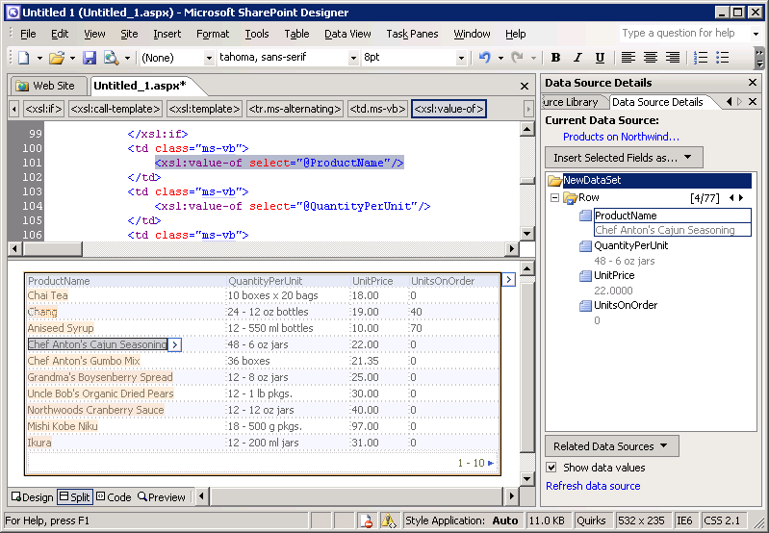

Figure : SharePoint Designer 2007 makes it easy to create data views from many sources at once.

Finally, Office SharePoint Designer 2007 also enables you to create flexible Web Part connections, so you can pass data between Web Parts. You can even build custom forms that write information back to external source files, including SharePoint lists, SQL Server databases, and XML files.

### Extend and Customize Downloaded SharePoint Applications

By the time Microsoft formally releases the 2007 Microsoft Office system, you will be able to download a range of prebuilt SharePoint applications from the MSDN® Web site and then use Office SharePoint Designer 2007 to refine them to meet your exact needs. More than 40 SharePoint applications will be available from the Microsoft TechNet Web site at launch. These applications, which will run using Windows SharePoint Services (version 3), range from applications to manage employee absences and vacation schedules to applications for capturing competitive intelligence, managing room and equipment reservations, and more.

Office SharePoint Designer 2007 in Action

Using the powerful site creation tools in Office SharePoint Designer 2007, Barbara quickly creates a brand-new SharePoint site where writers, videographers, and the Fabrikam product marketing team members can collaborate on the development of video case studies.

In addition to tracking the activities and status of the writers and videographers involved with the Fabrikam case studies, Barbara wants her SharePoint site to keep track of videotape stock. To accomplish this, she creates a data view Web Part that uses a table to display inventory data from a SQL Server database. Using the conditional formatting capabilities of Office SharePoint Designer 2007, Barbara formats the table to highlight the stock field when the inventory of a particular kind of tape drops below a specified point. She will then know that it is time to order more supplies.

# Automate Business Processes

If you are creating a SharePoint application to help automate a business process, the Workflow Designer component of Office SharePoint Designer 2007 opens up whole new possibilities. Built on Windows Workflow Foundation, a component of Windows SharePoint Services 3.0, Workflow Designer makes it easy to integrate business rules and workflow logic into your SharePoint applications—without writing any server code.

### Automating with a Rules-Based Workflow Engine

The Workflow Designer provides powerful capabilities for working with SharePoint lists and document libraries, including adding, modifying, copying, and removing items or documents; assigning tasks to people; routing documents for approval; and sending e-mail notifications.

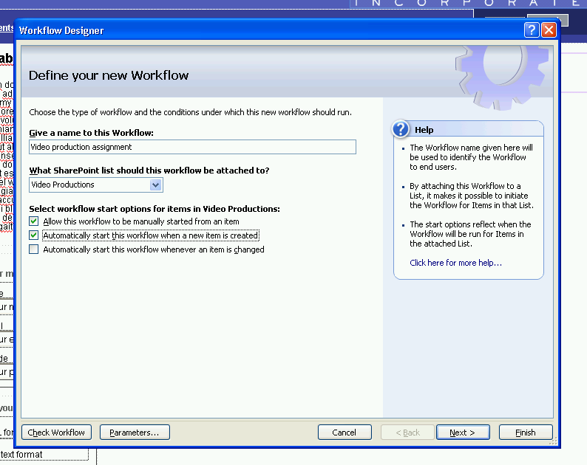

Figure : The Workflow Designer in Office SharePoint Designer 2007   
makes it easy to create powerful workflows.

Creating workflows is easy. The task involves identifying the conditions under which certain actions will occur and then selecting the actions to occur in response to those conditions. The Workflow Designer enables you to select conditions and actions from drop-down lists and check boxes. It then tests and checks the logic of the workflow and identifies any errors or inconsistencies, which you can eliminate before making the workflow available to others.

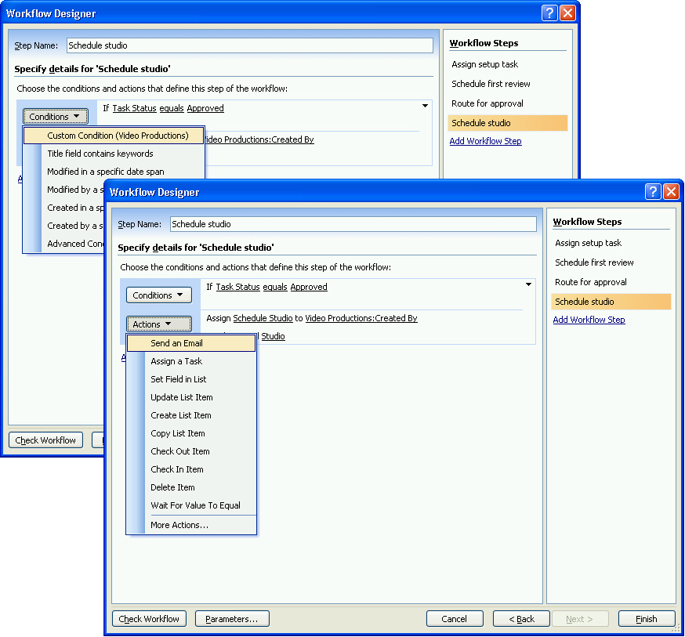

Figure : Workflow Designer enables you to select conditions and   
actions from drop-down lists and check boxes.

The Workflow Designer makes it easy to bind information in a SharePoint list to an action or event initiated by a workflow, too. If a step in the workflow involves sending an e‑mail message to get managerial approval to start a project, you can use Workflow Designer to create a generic e‑mail message with linked fields that pull specific details right from a SharePoint list. The message appearing in the manager’s inbox would then contain information that is specific to the project—its budget, due date, and project manager, for example—all of which comes directly from the SharePoint list.

### Revising Workflows as Needs Change

SharePoint workflows are validated by the server, compiled, and stored on the server as Extensible Object Markup Language (XOML) files. The code in these files cannot be edited directly from Office SharePoint Designer 2007. If you want to modify a workflow, you must load the workflow into the Workflow Designer, modify the workflow, and then resave the workflow. This prompts the system to recheck the workflow for appropriate permissions, revalidate the file, and recompile the code—all of which helps maintain the integrity and security of the SharePoint site.

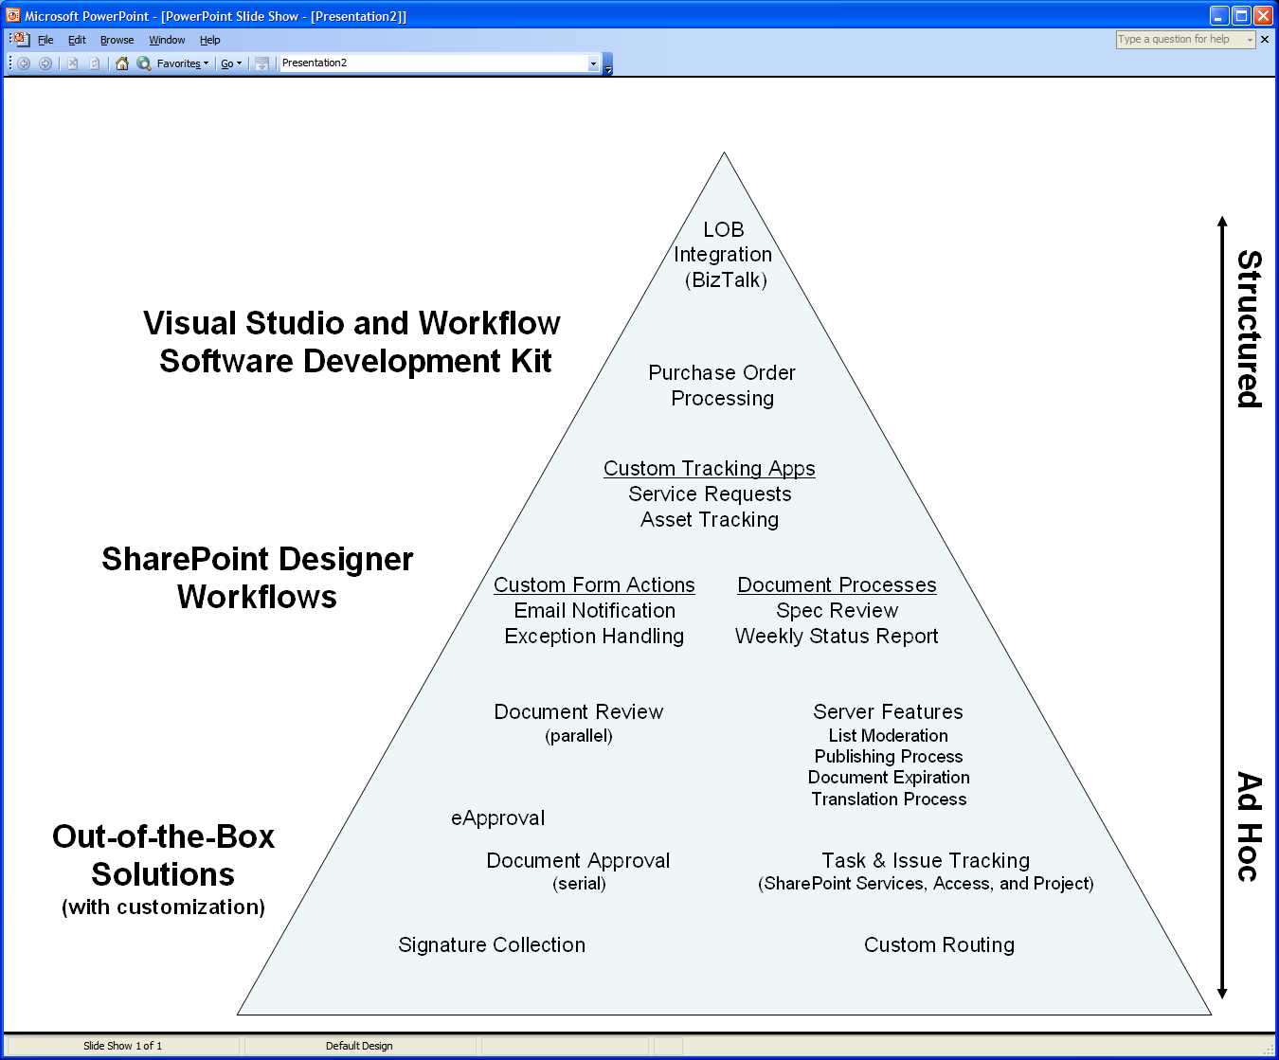

Figure : Office SharePoint Designer 2007 helps you develop no-code workflows quickly and easily.

Office SharePoint Designer 2007 in Action

Enabling the Fabrikam marketing managers to see the status of a given customer case study is one of the key goals of the SharePoint site, so Barbara takes advantage of the workflow capabilities of Office SharePoint Designer 2007 to help ensure that everyone knows when certain milestones are reached.

First, Barbara creates a New Project form for the marketing managers to use when initiating new case study projects. They will use these SharePoint forms to indicate the customer to be interviewed, the writer and video team that they want to use, and the subject matter experts (SMEs) who must review the case study drafts. Then Barbara uses the Workflow Designer to create a workflow to support the project. When a marketing manager completes a new project form, the workflow logic prompts SharePoint Designer 2007 to analyze the form and send all the participants an e‑mail alert to let them know that the project is beginning. One of the alerts goes to the group marketing manager, who, in turn, must respond to that e-mail message in order to authorize commencement of the project.

As soon as the writer uploads a draft of the case study script to the site, the same workflow system sends an e‑mail message to the SME associated with the project, informing this expert that the script is available for review. After the SME has reviewed the script, he or she can release the script for production, which in turn prompts the SharePoint system to alert the writer and videographer that they need to coordinate with the customer to set up a time to shoot the video itself. Barbara’s workflow is even automated to send a message to the customer to let them know that the writers and videographers will be contacting them shortly to set up a time to interview them on camera.

# Customize SharePoint Sites

Every SharePoint site starts with the same visual characteristics, so Office SharePoint Designer 2007 provides the tools you need to customize and create visually distinct SharePoint sites. You can use the master page capabilities of ASP.NET 2.0 to build and change SharePoint sites quickly and easily. You can tailor the presentation and look and feel of a SharePoint site to meet your needs and brand requirements using established Web standards such as XHTML and CSS.

### Build and Change Page Layouts Quickly

Office SharePoint Designer 2007 makes it easy to modify a SharePoint site. The WYSIWYG editor gives you a detailed view of the page and its elements. You can lay out tables and cells, even apply formatting to specific cells.

You can create new ASP.NET master pages to which you can link other pages on your site. Master pages can provide a foundation layout for one or more types of pages. They lay out information that will be common to each of these pages (a footer, for example, with links to other sites or services that users might want to access quickly). If you want to add elements or change the look of your site, you need only change the master pages. All the site pages that are linked to a master page adopt the new look rapidly.

With Office SharePoint Designer 2007, you can use master pages to build your own multipage site quickly, consistently, and with significantly less effort than it would take to create standardized pages one by one. This significantly increases your productivity and control.

Office SharePoint Designer 2007 also provides deep support for industry standard CSS, which you can use to further refine your master page layouts and formatting. You can take advantage of convenient, time-saving CSS tools such as task panes for managing, applying, and editing CSS rules and style sheets to design the look of your page. Office SharePoint Designer 2007 provides CSS property grids (with summary mode), a CSS Style Application toolbar, CSS layout tools, and Microsoft IntelliSense for CSS—all of which help ensure the rapid development of your customized SharePoint sites.

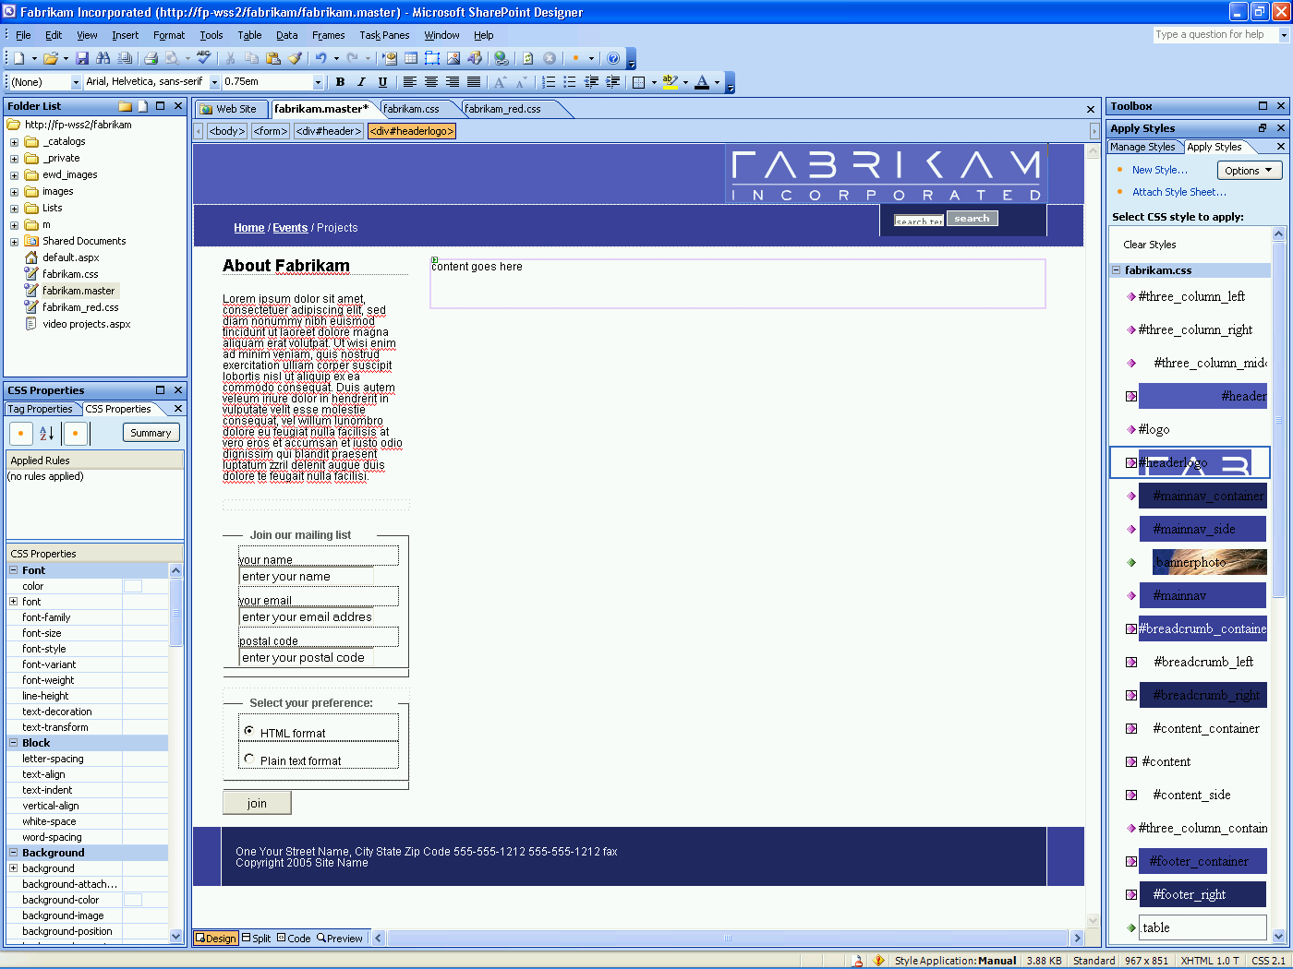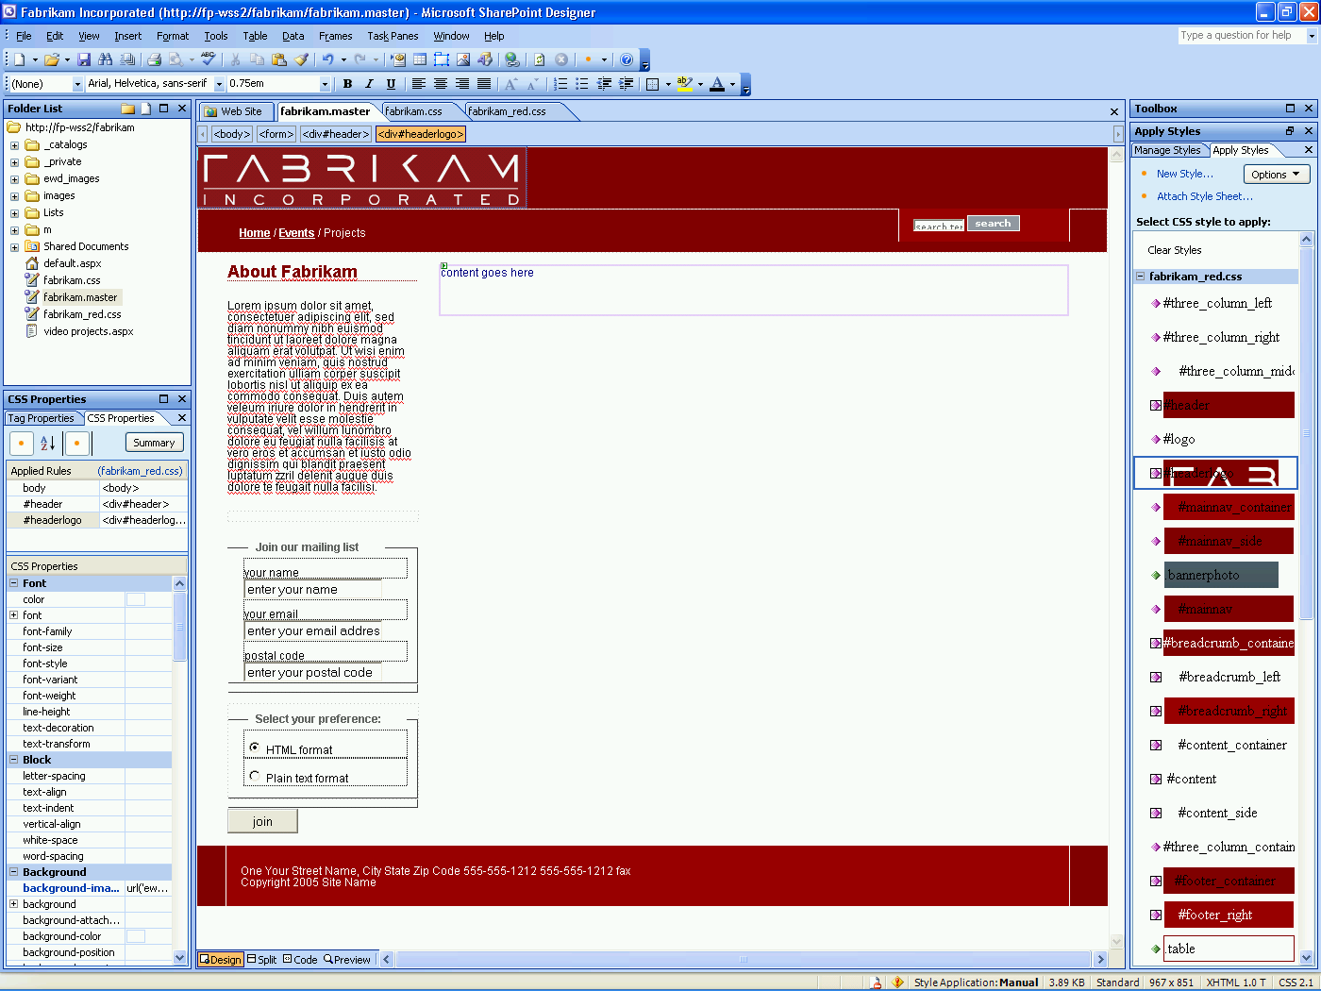

Figure : In Office SharePoint Designer 2007, master pages and cascading style sheets   
provide powerful capabilities for managing the look of a SharePoint site.

### Design Pages Productively

The tools with which you can refine and customize SharePoint sites are easy to access in Office SharePoint Designer 2007. Sixteen distinct task panes can help you identify and manipulate tag properties, CSS properties, and table and cell formats; they enable you to insert SharePoint and ASP.NET 2.0 controls, and more. You can open multiple task panes simultaneously, so you can see precisely the tools and information you want at a given time. You can dock and undock task panes—even pull the tab from one task pane and insert it into another for easy reference. And if you want to restore the task panes to their default settings, you simply click **Reset Workspace Layout** to do so.

In addition to the design view that enables you to see a SharePoint page in a WYSIWYG mode, a code view enables you to see the markup language code underlying the design. And if you want both the design view and code view at the same time, you can use the split screen view to see them in separate SharePoint Designer panes. Office SharePoint Designer 2007 also offers a preview pane that gives you a view of the page from within a browser—so you can experience all aspects of the page, including where each page element appears and how quickly they load—just the way a user would.

### Minimize Deployment Concerns with a Safety Net

After you have tuned the site to your liking, you can save it on your client system and prepare to upload it to a server running Windows SharePoint Services or to a Microsoft Office SharePoint Server system. If the site looks and works the way you expect, you can publish it to the server for others to use.

But what it if does not?

Not a problem with Office SharePoint Designer 2007. If your new master page does not look or work the way you want, you can revert it to its previous state by clicking the **Revert to Template** icon that appears next to the Master Page icon. Doing this restores the SharePoint master page that existed before you made your changes—and everything will work the way it had before.

Having reverted the master page, you can return to Office SharePoint Designer 2007 to refine your new site.

Office SharePoint Designer 2007 provides a similar safety net for cascading style sheets. If you want to modify an existing CSS, SharePoint Designer creates a local copy in the current site—so if your new CSS does something unexpected you can easily revert to the original.

### Find, Test, and Fix Problems Quickly

Office SharePoint Designer 2007 provides powerful tools for finding, testing, and fixing errors on your SharePoint site before you open it up to a wider audience. As noted earlier, SharePoint Designer includes Microsoft IntelliSense support, which helps you minimize errors when working directly in the code view with the markup language and tags that comprise the site, including:

* XHTML
* ASP.NET
* CSS
* XSLT
* XPath

As a consequence of the built-in syntax and tag structuring support that IntelliSense provides, your markup code is very clean from the start and you can bring a richly formatted site online very quickly. The Split View feature provides a contextual view of the portion of the code that you are working on—providing both a WYSIWYG view and a code view in the same pane. The Tag Inspector can validate the markup code as well as spot anomalies. You can even tune data transformations using live data with the XSLT editing capabilities of Office SharePoint Designer 2007.

In addition to the IntelliSense support, Office SharePoint Designer 2007 offers powerful compatibility and accessibility checking capabilities. The compatibility checker enables you to verify that the pages in your site comply with the Web standards you are targeting. For example, you can check to see that your pages are compatible with XHTML 1.0 Transitional and CSS 2.1 (or other combinations of CSS and HTML standards). Using the compatibility checker you can identify any areas of your site that do not behave as anticipated and fix the problems before your site goes live.

The accessibility checker evaluates your site from the perspective of the standards associated with Section 508 of the Americans with Disabilities Act. As with the compatibility checker, the accessibility checker can highlight those areas of your site that might be out of compliance with the standards associated with those regulations, and provide you with an opportunity to correct problems before going live with your site.

Office SharePoint Designer 2007 in Action

To customize her SharePoint site to meet the specific needs of her project, Barbara edits the default master page to create a layout consistent with her established company and department standards; she also adds key content elements that she wants to have appear on each page. Then she uses the CSS tools to modify the CSS that she has already defined for other organizations within Fabrikam. When she saves the master page, it automatically saves the embedded CSS. This helps to ensure the consistency of colors and typographical styles with other parts of Fabrikam. At the same time, Barbara knows that the company is rethinking color schemes at the moment, so she keeps an alternate CSS on hand that contains the proposed colors and typographical characteristics. She plans to discuss the advantages of each with her manager—and simply by changing the reference to the CSS she can present the site in either of the color and typography schemes.

After Barbara and her manager determine the appropriate color scheme to use, Barbara can save the master page with its link to the appropriate CSS. Each master page will quickly reflect the characteristics of the selected CSS, as will each page based on the master page.

# Manage Your Site with Confidence

After you have built, tested, and refined your SharePoint site to the point where it is ready for public access, you can upload it to an Office SharePoint Server. But how can you help ensure that site visitors and contributors will not inadvertently break it? Office SharePoint Designer 2007 provides powerful tools for managing contributor access

### Defining Contributor Settings and SharePoint Roles

A SharePoint site administrator or an organization’s IT department can use established SharePoint role definitions to define the broad actions that specific groups of users can perform. With Office SharePoint Designer 2007, however, the administrator or IT team can also use SharePoint contributor settings to refine the permissions enabled by the standard SharePoint roles—making it possible to specify exactly what, where, and how individuals can interact with the SharePoint site.

Office SharePoint Designer 2007 contributor settings provide increased control over what individuals can do within each defined SharePoint role. Office SharePoint Designer 2007 extends and refines the default SharePoint roles. For example, you could allow one group of contributors to add text, another to add text and images, and still another to add text and images and make layout changes. Office SharePoint Designer 2007 contributor settings make it easy for a SharePoint administrator or an IT department to lock or unlock features, define specific areas where contributors can read and save information, or identify which master pages and CSS files specific users can use to create new pages.

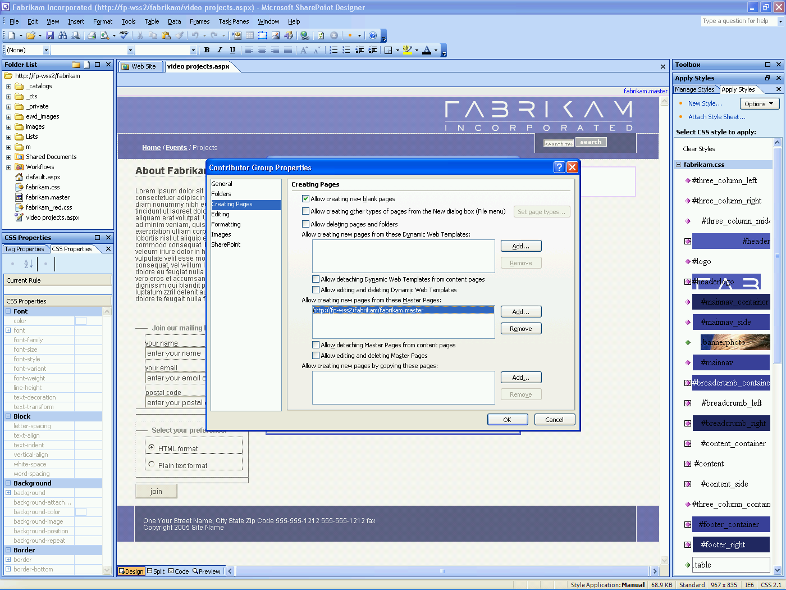

Figure : Office SharePoint Designer 2007 contributor settings make it easy to specify   
what users can and cannot do on a shared site.

### Protecting What Works

For IT groups and SharePoint site administrators, Office SharePoint Designer 2007 contributor settings enable them to allow optimal access and maintain optimal control. SharePoint Designer enables IT to map SharePoint roles to contributor settings in which they specify which features in SharePoint Designer can be used by members of each role. This helps ensure that users cannot accidentally break the site or inadvertently compromise the integrity of the shared resource.

Finally, there is the Revert to Template feature that provides protection within the site development realm as well. It enables site designers to test refinements to a SharePoint site and then—if the refinements do not work as you wanted or, worse, if they break the site—return the site to its previous state by clicking the **Revert to Template** icon.

Office SharePoint Designer 2007 in Action

Now that Barbara has built her case study site, she identifies the Fabrikam contributors who will need to interact with the site. Using the Office SharePoint Designer 2007 contributor settings, she refines the predefined SharePoint role settings to define exactly what users in each given role may and may not do on the site itself. For example, some users she restricts to adding only text; other users she allows to add text as well as images from the customer video shoots. She also specifies which folders users can update, leaving some off limits, thereby limiting the chance that a user might inadvertently overwrite a critical file.

Barbara checks the box on the contributor group properties page that authorizes users to create new pages on the site, but she does not check the box that allows them to delete or edit the master pages themselves, because she wants to help ensure that users can’t change the look and feel of the site in the course of adding new pages to the site. With such granular user definitions, Barbara makes it easy for her coworkers to update and edit their project pages without changing or breaking the entire site.

# Summary

Microsoft Office SharePoint Designer 2007 provides the powerful tools you need to build and customize SharePoint sites and interactive, workflow-enabled SharePoint applications. Its intuitive, WYSIWYG design interface and easy-to-use development tools help simplify the task of building your sites and applications—without writing and deploying any server code.

In addition, Office SharePoint Designer 2007 helps you maintain your site’s operation and internal integrity with confidence. Accessibility and compatibility checkers help ensure that your site conforms to industry standards for accessibility and that it is compatible with the browsers that your users are running. Site administrators or your IT department can use the contributor settings in Office SharePoint Designer 2007 to limit the degree to which contributors can modify the SharePoint site, which helps prevent inadvertent changes or site breaks. Office SharePoint Designer 2007 even enables you to revert updates to a SharePoint site. If the updated site does not behave as expected, you can return the server site to its previous state with the click of a button—so you never risk losing the original site.

The bottom line? Office SharePoint Designer 2007 is the preferred tool for those who want to build SharePoint applications or to design and customize SharePoint sites quickly, efficiently, and without writing code.

# Resources

For more information on Office SharePoint Designer 2007, please visit [www.microsoft.com/office/sharepointdesigner](http://www.microsoft.com/office/sharepointdesigner)

# System Requirements

For complete system requirements, visit [www.microsoft.com/office/sharepointdesigner](http://www.microsoft.com/office/sharepointdesigner).

This document is developed prior to the product's release to manufacturing, and as such, we cannot guarantee that all details included herein will be exactly as what is found in the shipping product. The information contained in this document represents the current view of Microsoft Corporation on the issues discussed as of the date of publication. Because Microsoft must respond to changing market conditions, this document should not be interpreted to be a commitment on the part of Microsoft, and Microsoft cannot guarantee the accuracy of any information presented after the date of publication. The information represents the product at the time this document was printed and should be used for planning purposes only. Information is subject to change at any time without prior notice.

This document is for informational purposes only. MICROSOFT MAKES NO WARRANTIES, EXPRESS OR IMPLIED, IN THIS DOCUMENT.

© 2006 Microsoft Corporation. All rights reserved. Microsoft, Expression, FrontPage, IntelliSense, MSDN, the Office logo, SharePoint, Visual Studio, and Windows are either registered trademarks or trademarks of the Microsoft Corporation in the United States and/or other countries. The names of actual companies or products mentioned herein may be the trademarks of their respective owners.