A step by step guide on how to install Apache 2.2.16 in Microsoft Windows

Module Introduction

Purpose:
Apache 2.2.16 [Release Date: 25-Jul-2010]: The reason the Website Administrator would install Apache HTTP server onto a computer is to enable him to serve webpages and/or other content on the World Wide Web, on an intranet or for personal testing before uploading his site live.
Those looking to install Apache 2.2.17 should use this guide to install their version of Apache. The wizard windows and setups have not changed. The software download link in these pages will now default to this newer version. There are some important improvements in the newer install over 2.2.16 and an upgrade is recommended. Also more support for has been added for various OS packages. If upgrading from 2.2.16, remember to use the windows uninstaller to remove this older version first. Backup your httpd.conf config file as a precaution, however, you should encounter no disruption to any other installed components. (Our Upgrade of 2.2.16 to 2.2.17 was a very simple process. We didn't need to alter any configuration files for Apache 2.2.17, PHP5.3.3 or MySql5.1.51) [These pages will more closely resemble 2.2.17 shortly. More later...] .
This module will instruct the Website Administrator on how to successfully use the apache windows installer to correctly install and configure Apache HTTP server on a Windows computer. If you are installing apache on Windows XP, Vista or a Windows7 based operating system, then follow each step in sequence.
If you plan to install your Apache server on Windows NT 4.0, Windows 2000 or other Windows operating system than those listed above, then please refer first to the notes in prerequisites.
The setup of a test system in comparison to that of a live system (www or intranet) will differ only in the section entitled Server Information. This module assumes the installation purpose is for a test server setup. The Administrator can also install PHP5 (or PHP4) and MySQL along side Apache under Windows to add greater functionality, perfect his skills or to demonstrate new experimental ideas with swiftness and ease.

Outcomes:
On completion of this module, the Website Administrator will have demonstrated that he has attained the necessary skills required to install and configure Apache HTTP server on a Microsoft Windows based Operating System. He will become familiar with how to locate and do a simple edit to Apache's main configuration file, httpd.conf. He will also learn how to modify the document root (the home directory) so that he can create any number of 'test website' directories and be able to point the config file to only one of these test websites at a time. This is very useful for any Website Administrator who tends after more than one website.
The more the Website Administrator understands, can and does use the basic tools of his trade, the better his service will be to his client base.

Which Apache Version 1.3 or Version 2.2?
As the Website Administrator, a major question to firstly resolve is which version of Apache should be installed on your system, version 1.3 or version 2.2? Your decision may be influenced by your desire or need to add further functionality to your HTTP Server in the future with add-on software programs like PHP5, or the older PHP4 (PHP is a very popular free server side scripting software which can add greater functionality to websites) or My SQL (a very popular free data base software).
The strongest argument against using the once very popular Apache HTTP Server version 1.3 is that this version has been declared as having reached it's "end of life". This means that the 1.3 version is no longer maintained.
The most recent release of Apache HTTP server version 2.3.6 is available in it's testing alpha Unix Source form. As Windows and Unix are not technically interchangeable and that our Windows installation will require the WIN32 version of the Apache HTTP Sever software in order to run on a Microsoft Windows environment, we will pass over this release version for now.
This brings us to the best recent and most stable WIN32 version available. This release also works well with a range of current contemporary third party software programs such as the previously mentioned PHP, My SQL etc., as these developers have already released compatible Windows installation software which will go in nicely with our 2.2 server. So the version we should want to install is Apache HTTP server Version 2.2.16

Notes on SSL:
An SSL [Secure Sockets Layer] allows the administrator to add encryption between the server and visitor. When a web page is actively using SSL, the web browser location bar will display the web page address beginning with https:// instead of the more common http:// location.
In this tutorial, the target download is the apache "no mod_ssl" version as many websites have little to no requirement for a personal SSL setup. If needed, many prefer to simply obtain an SSL certificate(s) from Trusted Suppliers for a variety of valid reasons to simplify the process of Trust. Especially in e-commerce scenarios.
To add SSL function, you can install a version of Apache HTTP Server in which Mod_SSL is included [available from the linked Apache downloads page below]. However, if you do plan to use an SSL function, your preference may be slanted to other SSL binaries like
- Apache-SSL: (Mod_SSL is not the same as Apache-SSL for more details)
- OpenSSL (Frequently Asked Questions for more details)
- Or other Apache compatible Third Party SSL installation
In a Third Party SSL binary scenario, you would first install the "no mod_ssl" version of Apache HTTP Server 2.2.16, then add and configure your Third Party SSL binary after this setup was complete.
For these reasons, and to keep this training guide simple, we download the Apache version which does not require any SSL setup at this time. If looking for a digital delivery solution etc., one can also easily expidite a sales process by using products such as those found in the LinkLok range (see below).

Download the software:
Selecting the next link will open a new window or tab and take you directly to the correct section of the downloads page and provides the most current version for your apache windows installer software. (Note: Newer release is httpd-2.2.17-win32-x86-no_ssl.msi)
- Official Website Download for Apache 2.2.16.
Scan down the immediate list of available download descriptions in that section until you find Win32 Binary without crypto (no mod_ssl) (MSI Installer) httpd-2.2.16-win32-x86-no_ssl.msi and select that file for download. It should automatically locate the nearest mirror site for a quick download. (You can view changes between versions 2.2.15 and 2.2.16 by viewing this link.)
The remainder of this apache tutorial will walk you through this apache HTTP server windows installer file so that it is functioning on your Microsoft XP, Vista, Windows 7 (or other MS OS Software with the prerequisites in place) Operating System. The Apache HTTP Server installer file is quite small in file size and will not take long to download.

Prepare for Apache 2.2.16 installation :
Before we begin our Installation of Apache HTTP server 2.2.16, and as we shall do with other major programs we intend to install along side Apache, like PHP or MySQL, we should note some system specific steps according to our Operating System.
For Vista, 2008 & 7, updating key configurations may be ignored if you have not set your permissions correctly for use with User Account Control (UAC). If you use UAC, configuration changes may be stored in the hidden user folder C:\ProgramData which the program expects to be made to files in C:\Program Files, C:\Windows etc. Config files in this folder can also cause problems when re-installing software. You should either know how to use UAC to grant the safest highest Privilege Levels or totally disable UAC by sliding the level controller into the Never Notify position. If you suspect UAC is causing you grief, this is a good simple UAC troubleshooting guide from Microsoft.com.
Most can skip this Port:80 check unless you have a problem testing your install at the end of this tutorial. Apache does not share the same TCP/IP port as other applications on the Windows Operating System. Other programs listening on port 80 (such as Skype or IIS) need to be stopped, uninstalled or have their configuration changed to an alternative port. To see what ports are in use, you can call up the command prompt [a Dos Box (Fig 00)] and type: netstat -n -a -b [press enter]. The resulting list informs you which port numbers are in use under the Local Address column (next to the name of the program which owns it). Type exit [then press enter] to close the DOS window.
Checking for Port :80 Conflicts
(Fig. 00)
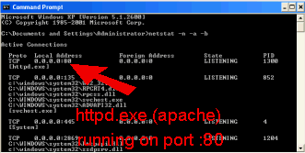
The install package does offer an alternative (port:8080) which will get around the port conflict issue as discussed in the "server information" section. If you chose this route, you will need to ensure you specify :8080 in your target urls. (eg. http://localhost:8080/index.html etc.)
You should have now downloaded your install file, and be ready to proceed to the next page and begin the software installation part of this tutorial.

Begin the installation:
Start your downloaded file: httpd-2.2.16-win32-x86-no_ssl.msi (double click or right click/run) and this training module will help step you through the data input selections the wizard will ask of you. The wizard starts with the following start-up screen (Fig. 01):

Starting the Apache HTTP Server 2.2 installation wizard
(Fig. 01)
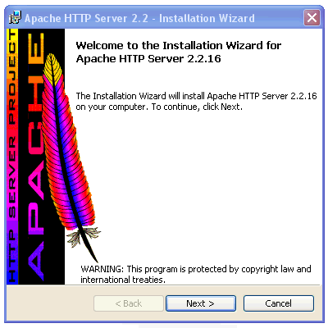
The Administrator will be wise to note that this same installer file can also be started to modify/repair/remove an existing installation. As this is our first installation, the only option we will be presented with is to install the server software. Select next to move to the next part of our Apache HTTP server 2.2 installation.

Accepting the License Agreement:
The second window loads the License agreement into the viewing panel (Fig. 02). The provided scroll bar enables you to view the entire contents of the agreement. Check over the details to be sure you are happy and willing to comply and accept the conditions as laid out for your use of the software. If all is acceptable, select the radio button in front of the phase I accept the terms in the license agreement and then choose next to continue the installation process.

Apache HTTP Server 2.2 License Agreement Screen
(Fig. 02)
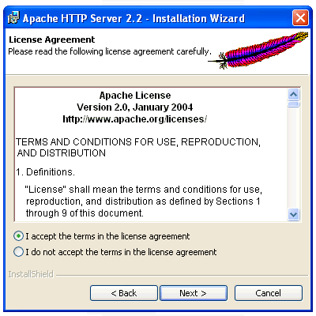
[Back to Apache 2.2 Installation Guide Index]

The Apache user community:
Our next window (Fig. 03) is quite brief and will give us some useful information like where to subscribe should there be desire to keep abreast of new code releases, bug fixes, security fixes and other general news or information for your Apache server. Visit, bookmark or subscribe to anything of interest and then choose next to move to the next stage of the installation process.

Introducing the Apache HTTP Server community
(Fig. 03)
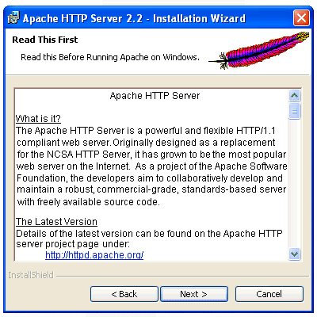

Entering your Server Information:
Our next window (Fig. 04) is of extreme interest to the Website Administrator as it defines our exact network location in terms of our DNS domain.
If we were establishing a www set-up, this step would be of elevated importance and would look something like this: server.mydomain.com. This full name would be our Server Name (The second line in our form in Fig. 04).
mydomain would of course be replaced with the duly registered domain name of your website (or that of your dns server).
Our network name is the last part of this address: i.e. mydomain.com (This becomes the first line in our form in Fig. 04).
Notes: Configuring your Apache Server For the Web. A DNS (Domain Name Server) is like a large telephone book which computers on the internet use to find a website. Most people like names better than a bunch of numbers. For example, if you go to 72.14.213.99 in your web browser, you will see you have arrived at Google.com. Most people would rather remember www.google.com than a series of dots and numbers.
For home users, when an ISP changes your IP, the full DNS number changes and so your web server can not be found unless you re-configure the server each time and give your new number address to your friends, businesses etc. Now home users can get a personal DynDNS (see link below) that will solve this problem. This is very easy to configure too and is very much like what you have just learned. To start, get a premium or cheap domain name(s) and request for the free DynDNS service to be activated for your favorite domain name choice. This will become your permanent website address. You can then setup and run that website address with Apache HTTP Server from your home (or office) computer. Your friends and customers will always be able to find you.
Some people also like to monopolize their website name in as many different domains as possible because Google's SEO formula can be dependant on the website's geographical DNS location e.g. .com.au, .uk, .it etc. This also stops other people cashing in on your idea or brand name. You can search and register Domain names or get DynDNS here. (Europe, Asia, Oceania, America etc. etc.)
And as the purpose of this tutorial is to place a server setup on a local network to further familiarize the website administrator with Apache, we will gloss over this point for now and define our DNS domain as a local domain only.
Entering the DNS domain details of our Apache HTTP Server
(Fig. 04)
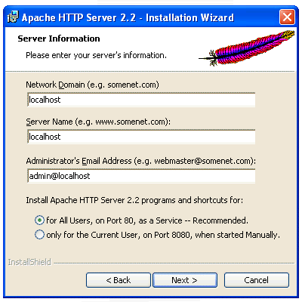
We enter "localhost" as our Network Domain, and we also enter "localhost" as our Server Name. You can name any email address you like as the administrator's email. If we wanted to secure a domain first, or use DynDns, we used the link above and can either use the data now, or we can add them after we have setup apache.
Next we want to ensure our network users can find our server and we setup their shortcuts by choosing the radio button marked for All Users, on Port 80, as a service -- Recommended and select next to continue with the installation process. Note: If you select Port 8080, you will need to stipulate this port when calling your network. eg. http://127.0.0.1:8080/ or http://localhost:8080/index.html
Some Vista Operating System users may opt to use port 8080 if they are unable to resolve any port 80 conflicts as mentioned in page 1 of this guide.

Setup Type:
Next we are asked to specify the type of installation we want (Fig. 05). Typical is fine for our purposes, so we select typical and then select next.
(Note: If you would really like to see what is installed with this Apache software, you can select "custom", then "next" to see what components will be installed. Then select the "back" button to return to this window. This time choose "Typical" and then "next" to continue with the install as normal.)
Choosing the setup type best suited to our needs.
(Fig. 05)
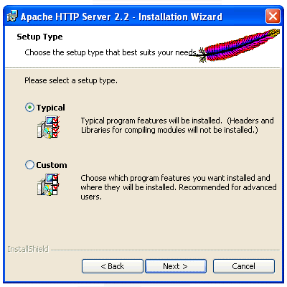

Custom Setup :
Most users can safely skip the custom setup step (Fig. 06) and simply use the default install option. A custom installation is not required to install and setup either MySql nor PHP.
Custom Setup offers the ability to compile and link further Apache Modules. If you know you need to, or wish to add this feature (see Fig. 06, highlighted in RED below with it's description on the right), select the menu item with the red X and choose This feature will be installed on the local hard drive from the drop down menu that is presented to you.
If you have selected a custom install, you would also confirm your installation directory at this point. The default destination is recommended.
"Space" allows you to check how much hard disk space is free on your drives while "Help" will display a key for icons used on this window.
(Note: You can easily add/remove any feature at any time by simply restarting this 2.2.16 installation file after the program has installed.)
Apache's custom install menu .
(Fig. 06)
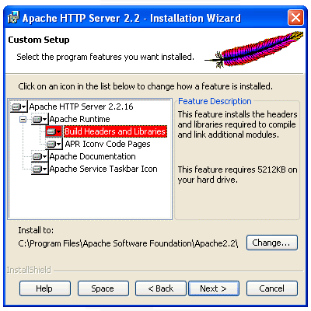

Destination Folder :
If you selected the Typical Install option, your next window will be the Destination Folder (Fig. 07). Like most programs, using the default destination folder makes life easier for those new to any software and Apache is no different. This step allows you to change exactly where apache is installed on your drive(s). However, most of us will simply select next.
Apache Destination Folder.
(Fig. 07)
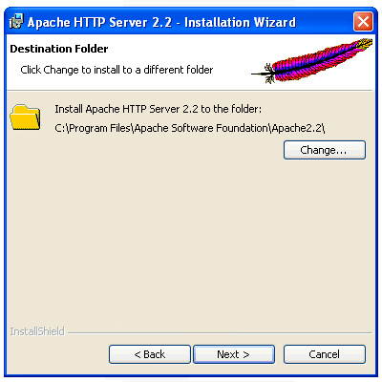
[Back to Apache 2.2 Installation Guide Index]

Installing and testing:
You are now ready to install your apache HTTP server. Select "install" (see fig. 08).
Ready to Install the Program .
(Fig. 08)
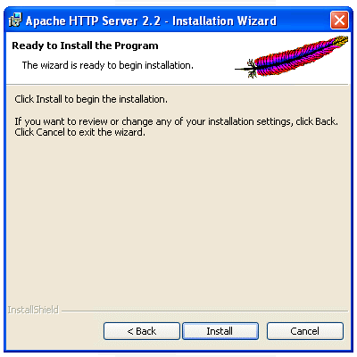
The Apache installer now installs the required files into your system with the parameters we have selected.
Upon completion, you should note a new icon in the system tray which will tell you if your server is in a running or stopped state.

System Tray Server Status Icon.
(Fig. 09)
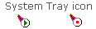

If your Apache HTTP server 2.2.16 is running properly, you will see the icon with the green triangle inside. If not, use the start menu and find the configure apache server menu. Here you will find the test configuration link. Select this and you will either see a test window that will shut almost as quickly as it opened (this means all is fine) else you will be shown an error which will need to be corrected.
After testing your server, and if you have completed a default installation, you can also check for any server error.log errors by browsing to: C:\Program Files\Apache Software Foundation\Apache2.2\logs\error.log.
The administrator can easily manually start, stop or restart the server using this system tray icon (Fig. 09). Place the mouse cursor over the apache icon, depress the left mouse button, slide up to apache 2.2, and then select the server state required from the list. Right clicking the icon offers a more advanced range of options. To test your server, ensure the server is started and then simply initialize your internet browser and type either:
http://127.0.0.1
or
http://localhost
into your browser location bar and press the "enter" key on your keyboard. (You can also copy and paste the above links into your browser).
If everything is fine, you will be greeted with "It Works!" or if you have altered your home page directory as per the notes below, you will be greeted with "Index of/" and if this directory is one that already has a bunch of stuff inside it, you will see all your files listed there. Else, throw together a quick index.html, php test page or even a couple of .gif images or a .txt file into that directory so you have something to see.
If you have a problem with the localhost command, you can check your hosts file (there is no "." extension on this file) by browsing to C:\WINDOWS\system32\drivers\etc and opening the hosts file with notepad. If this next line is missing, add it then save the file. Re-start apache and try testing the above links again.
127.0.0.1 localhost
Let's now learn how to change the home page folder. You can point this apache home directory to any one of your test websites on your computer workstation. You can also repeat this next step at any time to point to another test website when switching between different website administration jobs.

Home directory/folder:
Your home directory (folder) and in a standard installation this is located at:
C:/Program Files/Apache Software Foundation/Apache2.2/htdocs/
This is also called our document root and is where you would place your index.html file and all other media you plan to test or serve from this server. You would add any needed sub-directories from this root. Eg. an images or thumbs sub-directory.
You can also change this document root directory. This is especially handy if you administrate more than one website. If each website you administer has it's own directory, you can set that directory as the document root very easily. By doing this before you begin modifying each of your clients websites, you can fully test the interaction of an entire website before you take that website live with your changes. Let's learn how to do this.

How to Change the Document Root:
If you would like to change your document root (root directory), you can do so by editing two lines in the the Apache httpd.conf file.
The httpd.conf is the Master Configuration File for your apache server and can be found by exploring the location C:\Program Files\Apache Software Foundation\Apache2.2\conf\ on your computer. We can also gain access to this configuration file from the windows start menu through the Apache HTTP Server 2.2 program group by selecting Configure Apache Server and then selecting the shortcut titled Edit the Apache httpd.conf Configuration File.
The first line we wish to edit is: DocumentRoot "C:/Program Files/Apache Software Foundation/Apache2.2/htdocs" (Note: make sure you read the line correctly and that you only change the line that says DocumentRoot and not the line which states ServerRoot.).
When you have located the DocumentRoot line, the administrator can then modify this to suit his preferred location eg. DocumentRoot "C:/public_html"
The second line we edit is only a few lines below our first edit and modifies apache's directory tag which we alter to: <Directory "C:/public_html"> (Note that both edits have identical paths as they both point to the exact same location).
It is better to personalize this folder to suit your needs like for example; "C:/www_campisi_pizza_website" or what ever makes it easier for you to locate each client among the list of client sites that you manage. Make sure you have created the folder/directory called public_html (or www_campisi_pizza_website) and place the applicable website files into that directory for this to work correctly.
If you plan to add password entry to your site, it is better to make the document root a couple of sub-directories in. eg. "C:/websites/campisi_pizza/public_html" The reason for this is that you will probably want to keep your password files off the web and away from search robots. This enables you to do this. Make sure you reflect any change in the Directory and DocumentRoot locations in the Apache httpd.conf file as you have now learned to do.

Always restart Apache after configuration changes
After you have completed these edits, you would also need to restart the apache service for the changes to take effect. So we click our apache icon in the system tray (or use the newly installed Apache HTTP Server 2.2 program group menu and named control apache server which you can access from the Windows start button - All Programs menu) and select restart to reinitialize the service with the new configuration. That's it!

Module Completion
If you are confident with what you have learned here, then you have also gained a couple of very basic entry level skills into handling your apache server. Pat your self on the back, you have completed this module course.

Formal Recognition
Did you gain an ability from this module? You can have formal recognition with your name added to our official "Installing Apache 2.2 on Microsoft Windows Course Graduates page". Great for your on-line resume or as a promotional link for your business!
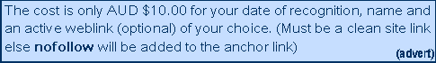
Examination consists of a series of true-false and multiple choice questions designed to explore your knowledge and understanding of the salient points of the requisite skills as stated in the outcomes section of this module. All graduates pass with a 100% grade. No extra cost for needing to re-sit the exam. Email now for details.
Module Length:
- 1 Hour

Pre-requisites:
The website administrator has previously attained the following computer skills:
- Ability to download an installation file and execute it.
- Ability to edit a plain text file (eg. use notepad).
- Ability to rename a folder or directory using either Windows Explorer or My Computer.
Applicable OS Platforms :
- Windows 7
- Windows Vista
- Windows XP
- Windows 2000
- Windows NT 4.0

Other Software-requisites: (for NT 4.0 or 2000 only)
- NT 4.0 & Windows 2000 require Microsoft Installer 2.0 (InstMsiW.exe) (download file InstMsiW.exe 2Mb)
- Windows NT 4.0 requires Service Pack 6 to work correctly (SP6a spi386.exe) (download file spi386.exe 34Mb [32bit version])

Hardware-requisites: (All)
- x86 family processor (eg. Intel, AMD)

